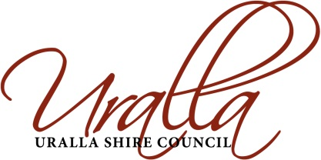

Planning Proposal
April 2018

TABLE OF CONTENTS

TABLE OF CONTENTS 1
PART 1 - OBJECTIVES OR INTENDED OUTCOMES 2
Location 2
Background 2
Current Context 3
Summary 3
PART 2 - EXPLANATION OF PROVISIONS 3
PART 3 – JUSTIFICATION 3
Section A – Need for the Planning Proposal 3
Section B – Relationship to strategic planning framework 4
Section C – Environmental, Social and Economic Impacts 5
Section D – State and Commonwealth interests 6
PART 4 -MAPPING 6
PART 5 – COMMUNITY CONSULTATION 6
PART 6 – PROJECT TIMELINE 7
ATTACHMENT 1: LOCATION OF LOT 30 IN DEPOSITED PLAN 793510 8
ATTACHMENT 2: LOCATION OF LOT 14 IN DEPOSITED PLAN 787477 9
ATTACHMENT 3: ANALYSIS OF NET COMMUNITY BENEFIT CRITERIA 10
ATTACHMENT 4: CONSIDERATION OF RELEVANT STATE ENVIRONMENTAL PLANNING POLICIES (SEPPs) 14
ATTACHMENT 5: CONSIDERATION OF SECTION 9.1 MINISTERIAL DIRECTIONS 16

PLANNING PROPOSAL

Uralla Local Environmental Plan 2012 Amendment of Land Classification

PART 1 - OBJECTIVES OR INTENDED OUTCOMES

The Objectives of the Planning Proposal are:
- To reclassify land presently classified as community to operational.
- To achieve better alignment between the current use and the land classification.

The intended outcome is to amend the Uralla Local Environmental Plan 2012 (ULEP 2012) Schedule 4 – Classification and Reclassification of the land to achieve better alignment between the current use and the land classification.

Location
The subject lands are identified as Lot 30 in Deposited Plan 793510 (Lot 30 DP793510) Queen Street, Uralla and Lot 14 in Deposited Plan 787477 (Lot 14 DP787477), Rowan Avenue, Uralla. The land is owned by Uralla Shire Council.

The Uralla Caravan Park is located on Lot 30 DP793510 and adjacent Crown Land through Permissive Occupancy (AE88H47) which includes the unformed section of King St. It has an area of 3700m². It is proposed to reclassify Lot 30 DP793510 as operational. Refer to Attachment 1 – Location Plan.
Lot 14 DP787477 is located on the western side of Rowan Avenue and is on the outskirts of Uralla on the New England Highway leading to Tamworth. To the north west is the Uralla Landfill. It has an area of 4.83 ha. Refer to Attachment 2 – Location Plan.

Background

Lot 30 DP793510 was acquired by Council in 1990 through excision from the Crown land Reserve for Alma Park for operational purposes to allow for operation of the existing caravan park. As such, the operational classification is most appropriate for the land although it has defaulted to community in the absence of any action to classify it in the appropriate manner.
In 2013 Council put forward the reclassification of Lot 30 DP793510 in a planning proposal. A public hearing was undertaken as per the provisions of Sections 56 and 57 of the Environmental Planning & Assessment Act 1979, and Section 29(1) and 47G of the Local Government Act 1993, by Mr Gerry Moran on 16 October 2013. His report (5 December 2013) concluded:
Considering all the submissions made regarding the reclassification of this land, at the public hearing and the written submission received by Council during the exhibition period, and the relevance to the Local Environmental Plan process, I conclude there are no issues arising that would prevent Council reclassifying the abovementioned land as operational in the Local Environmental Plan.

Further his report recommended:

Council reclassify the land contained within this report as operational land subject to the section of Alma Park currently being used for the overflow of the Uralla Caravan Park reflect its use either by acquiring part of the park as free hold or by way of Permissive Occupancy.
Council resolved at its Ordinary Meeting on 16 December 2013 to deviate from the original planning proposal by choosing not to alter the classification of the land, thus is remained as community land.
Lot 14 DP787477 was purchased by Council on 30 June 2016 for the purpose of ensuring there is suitable land available to meet opportunistic industrial needs that arise in Uralla. The land is capable of being developed with around 23 lots, depending on the subdivision model adopted. In this regard a number of preliminary layout models have been drafted and are still being critically examined.

At the end of 2017 the then lessee of the Uralla Caravan Park advised that the property would be vacated on the 30 January 2018 and operations on the site would cease. Interim arrangements have been put in place to continue the operations of the caravan park utilising Council staff. Council has historically engaged a third party to operate the Council owned Caravan Park at Queen Street, Uralla under a lease arrangement which has now ended.

The caravan park is located on lands owned by Council, and Crown Lands occupied under a Permissive Occupancy. The Permissive Occupancy has expired and NSW Department of Industry – Land’s staff have more recently advised that they are preparing a licence in favour of Council over the previous permissive occupancy area that will allow Council to operate, or lease, the area for the purposes of a caravan park.

Apart from the caretaker’s residence most of the sites and fixed infrastructure is located on the Council owned site at Lot 30 DP 793510.

Summary

The planning proposal represents an important amendment to the Uralla Local Environmental Plan 2012 to provide for land to be utilised in future to respond to the needs of Uralla residents and the wider community.

PART 2 - EXPLANATION OF PROVISIONS

The proposed amendment will amend Schedule 4 of the Uralla Local Environmental Plan 2012 (ULEP 2012) to reclassify Lot 30 DP793510 and Lot 14 DP787477 from Community to Operational land.

PART 3 – JUSTIFICATION

Section A – Need for the Planning Proposal

A1. Is this planning proposal a result of any strategic study or report?

There is no relevant strategic study.

A2. Is this planning proposal the best means of achieving the objectives or intended outcomes, or is there a better way?

The planning proposal is the only legal method of amending the ULEP 2012 to reclassify the land from Community to Operational to provide for future community uses and to dispose of the land. In accordance with LEP Practice Note PN16-001 Council is not seeking Delegated Authority to make this LEP.

A3. Is there a net community benefit?

There is a net community benefit associated with the proposed amendment to the ULEP 2012. Refer to ATTACHMENT 3 for the analysis of the net community benefit criteria.

It is considered that the resultant community benefit significantly outweighs the administrative cost of implementing the proposal.

Section B – Relationship to strategic planning framework

The New England Development Strategy 2010 (the Strategy) was prepared for the New England Strategic Alliance Councils. The Alliance comprises the four local government areas (LGAs) of Armidale Dumaresq, Guyra, Uralla and Walcha. The Strategy (adopted April 2010) outlines key land use policies and principles for the four LGAs and provides the planning context for the preparation of local environmental plan (LEP) provisions. The Strategy has a time frame of approximately 25 years, to 2032.

In relation to industrial land within the town of Uralla it states:

Section 6.2 Industrial land provision

………Although there is adequate undeveloped land currently zoned for industry, there is a perceived shortage of developed industrial lots available on the market in the towns of Uralla and Guyra. The main issue appears to be the limited choice of zoned industrial land, with the current owners of zoned land not yet proceeding to service and develop the land. As a result, alternative locations for industry and employment need to be identified to provide a more competitive market in Uralla and Guyra.

Objectives – Industrial land provision

- Provide adequate industrial land to meet demand for development and enable employment opportunities.

B1. Is the planning proposal consistent with the objectives and action contained within the applicable regional or sub-regional strategy?

The New England North West Regional Plan 2036 was approved and released on 23 August 2017. The regional plan has relevance to the planning proposal in several sections including:

Direction 6 – Deliver new industries.
Direction 7 – Build strong economic centres.
Direction 13 – Expand emerging industries through freight and logistics connectivity.
Direction 17 – Strengthen community resilience.
Direction 18 – Provide great places to live.
Direction 19 – Support Healthy, safe, socially engaged and well connected communities.

B2. Is the planning proposal consistent with the local council’s Community Strategic Plan, or other local strategic plan?

The Community Plan is silent on any specific mention of the subject land. There is nothing about the proposed reclassification of the subject land that is inconsistent with the Community Strategic Plan.

The proposal is also consistent with Uralla Council’s Community Strategic Plan 2017-2027 (CSP). The CSP was formulated and subject to an extensive consultation process in the first half of 2017 and was adopted by Council on 27 June 2017. The CSP has relevance to the planning proposal in several sections including the following:

Goal 2.1: An attractive environment for business, tourism and industry.

Strategy 2.1.1: Promote the Uralla Shire and the region as a wonderful place to live, work, visit and invest.

Strategy 2.1.2: Promote the Uralla Shire to business and industry and increase recognition of the area’s strategic advantages.

Goal 2.2: Growing and diversified employment, education and tourism opportunities.

Strategy 2.2.1: Provide land use planning that facilitates employment creation.

Strategy 2.2.2: Support and encourage existing business and industry to develop and grow.

Strategy 2.2.3: Support the attraction of new businesses, including sustainable employment generating projects.

To this end, Council has sought to provide additional development opportunities for industrially zoned land and believes that the Uralla Caravan Park provides an important function in terms of long and short term affordable accommodation with residents contributing to the local economy.

There is no other Local Strategic Plan to consider.
B3. Is the planning proposal consistent with applicable State Environmental Planning Policies (SEPPs)?

Refer to ATTACHMENT 4 – Consideration of Relevant SEPPs.

B4. Is the planning proposal consistent with applicable S.9.1 Ministerial Directions?

Refer to ATTACHMENT 5 – Consideration of S.9.1 Ministerial Directions.

Section C – Environmental, Social and Economic Impacts

C1. Is there any likelihood that critical habitat or threatened species, population or ecological communities, or their habitats, will be adversely affected as a result of the proposal?

It is considered that there is no likelihood of any adverse impact on critical habitat or threatened species.

C2. Are there any other likely environmental effects as a result of the planning proposal and how are they proposed to be managed?

It is considered that there is no likelihood of other environmental effects resulting from this planning proposal.

C3. How has the planning proposal adequately addressed any social and economic effects?

Refer to the community benefit established at ATTACHMENT 3.

Section D – State and Commonwealth interests

D1. Is there adequate public infrastructure for the planning proposal?

There are established utilities with an adequate public infrastructure support system in the Uralla Caravan Park (Lot 30 DP793510).

Currently, there are no services to Lot 14 DP787477, however they are available, and will be constructed once a definite subdivision layout for the industrial site has been finalised.

D2. What are the views of State and Commonwealth Public Authorities consulted in accordance with gateway determination, and have they resulted in any variations to the planning proposal.

Consultation will be undertaken in accordance with the requirements of a Gateway Determination.

PART 4 -MAPPING

The proposed amendment will not affect the Uralla Local Environmental Plan 2012 Mapping.

PART 5 – COMMUNITY CONSULTATION

A community consultation strategy for this planning proposal will be implemented to engage stakeholders and general public. The engagement process will involve displays at Council offices, media releases, public notices and interviews with residents and stakeholders upon request.

This planning proposal is required to be on public exhibition for a period of 28 days.
Once a Gateway determination to proceed has been received, Council will undertake community consultation in accordance with that determination. It is anticipated that consultation will proceed along the following lines:
- Notification in the local newspaper (Armidale Express);
- Notification on Council’s website; and
- Written notification to the adjoining landowners (Councils all subject land and has resolved to seek its reclassification)
In addition, notification will be provided in Council’s monthly newsletter which is circulated to all residents.
In addition to that above public consultation, Council is required under the Local Government Act 1993 to conduct a public hearing. The public hearing will be foreshadowed in the above information and will be formally notified at the completion of the exhibition period in accordance with the Act as follows:
- Give notice of the arrangement for the public hearing in a local newspaper, and
- Give notice in a letter to each of the persons who requested a public hearing when making a submission, at least 21 days before the date of the hearing.

The public exhibition and public hearing will be undertaken in accordance with the relevant legislation and the requirements of a Gateway Determination.

PART 6 – PROJECT TIMELINE

The table below provides an indication of the timeline for the planning proposal.

Anticipated commencement date (date of Gateway Determination) | June 2018
Anticipated timeframe for the completion of technical information | Studies complete
Government agency consultation | Subject to Gateway Determination requirements
Commencement and completion dates for public exhibition period | June (28 days)
Dates for public hearing (if required) | September 2018 (21 days following close of exhibition
Timeframe for consideration of submissions | October 2018 – dependent on the level of community interest in the proposal
Timeframe for further consideration of the proposal | 2 weeks – dependent on the level of community interest in the proposal
Date of submission to PCO and the Department to finalise the LEP | November2018
Anticipated date Council will make the plan (if delegated) | Not Applicable
Anticipated date council will forward to the Department for notification | December 2018

ATTACHMENT 1: LOCATION OF LOT 30 IN DEPOSITED PLAN 793510

LAND CLASSIFICATION PLANNING PROPOSAL

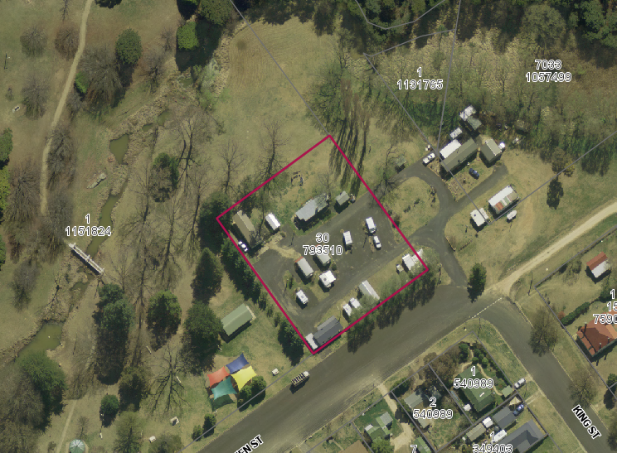

Source: Uralla Shire Council GIS System

ATTACHMENT 2: LOCATION OF LOT 14 IN DEPOSITED PLAN 787477

LAND CLASSIFICATION PLANNING PROPOSAL

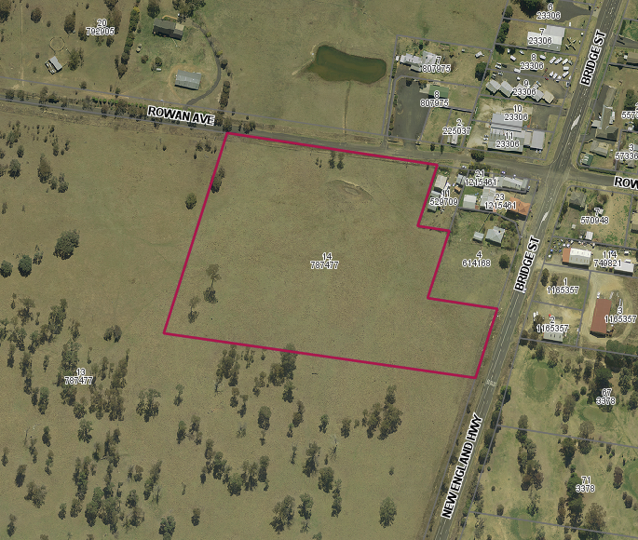

Source: Uralla Shire Council GIS System

ATTACHMENT 3: ANALYSIS OF NET COMMUNITY BENEFIT CRITERIA

ASSESSMENT RELEVANT TO LAND CLASSIFICATION PLANNING PROPOSAL

EVALUATION CRITERIA  YES/NO (or other comment as applicable) | COMMUNITY COSTS AND BENEFITS
EVALUATION CRITERIA  YES/NO (or other comment as applicable) | BASECASE – CURRENT SITUATION (or COMMENT) | PLANNING PROPOSAL | COMMUNITY BENEFIT PER CRITERION
Is the planning proposal compatible with agreed State and regional strategic direction for development in the area?  YES | The proposal is compatible with the new England North West Regional Plan 2036 prepared by the Department of Planning and Environment and the New England Development Strategy 2010. | The Planning Proposal provides the potential to establish other uses on the subject lands, (in full or in part) in future without prejudicing the use of the land. | The reclassification of the land will benefit the community by providing for future uses on the land as appropriate.  Additional benefits may include an increase in services to the community and employment opportunities generated by the community facilities. A community benefit is identified for this criterion.
Is the planning proposal located in a global/regional city, strategic centre or corridor nominated within the Metropolitan Strategy or another regional/sub-regional strategy?  NO | Uralla is not considered to be global or regional city, rather a small rural town. It does have an important presence in the New England North West Region, being located between Armidale and Tamworth on the New England Highway. | The proposed changes to the lands are supported by the goals identified by the New England North West Regional Plan 2036 for delivering new industries, building economic centres, expanding emerging industries through freight and logistics connectivity, community resilience, healthy and well connected communities. | The New England North West Regional Plan 2036 supports the delivery of industrial capability, expanding industrial opportunities through freight and logistics connectivity, location of community services and facilities to serve the public in the immediate area and are well planned to provide services to the wider Northwest Region. A community benefit is identified for this criterion.

Is the proposal likely to create a precedent or create or change the expectations of the landowner or other landowners?  NO | The owner of the land is Uralla Council.  The site is surrounded by private and public land being either industrial or residential, and parkland. | A change in classification will provide the opportunity for Council to facilitate future uses on Lot 30 DP793510 and create industrial opportunity on Lot 14 DP787477. | A change in classification will provide the opportunity for council to facilitate future uses on both lots. It is considered that the planning proposal may be benefit/cost neutral for this criterion.
Have the cumulative effects of other rezoning proposals in the locality been considered?  What was the outcome of these considerations?  N/A | No spot rezoning have been undertaken in the locality. | Not Applicable | Not Applicable
Will the planning proposal facilitate a permanent employment generating activity?  YES | Lot 30 DP793510 is currently used as a caravan park.  Lot 14 DP787477 will create employment as industry is developed on the land. Previously the industrial land has been held in a monopoly situation with no IN1 or IN2 zoned land being developed. Council has chosen to purchase the land as a whole and develop to provide additional development opportunities for industrially zoned land | It is proposed to reclassify Lot 14 DP787477 from Community to Operational classification to provide for future uses that may entail substantial employment opportunities. | Potential employment opportunities will be created as the industrial land is developed.  A substantial community benefit is identified for this criterion.
Will the planning proposal impact upon the supply of residential land and therefore housing supply and affordability?  YES | Lot 30 DP793510 is zoned RE1 – Public Recreation and Lot 14 DP787477is zoned IN2-Light Industrial both having Community classification. | The zoning for both lots will remain unaltered.  The caravan park provides an important function in terms of long and short term affordable  Accommodation, with residents contributing to the local economy. | A community benefit is identified in relation to this criterion.

Is the existing public infrastructure (roads, rail, utilities) capable of servicing the proposed site?  Is public transport currently available or is there infrastructure capacity to support future public transport?  YES | Utilities are provided to both lots. Lot 14 DP787477 has frontage to the New England Highway and Rowan Avenue. | The proposal provides both lots being able to take advantage of infrastructure, utilities and public transport services. | A community benefit is identified in relation to this criterion.
Will the proposal result in changes to the care distances travelled by customers, employees and suppliers?  NO  If so, what are the likely impacts in terms of greenhouse gas emissions, operating costs and road safety? | No changes to the care distances travelled by customers, employees and suppliers has been identified. | Not Applicable | Not Applicable
Are there significant Government investments in infrastructure or services in the area whose patronage will be affected by the proposal?  NO  If so, what is the expected impact? | No significant Government investment or infrastructure will be affected. | Not Applicable | Not Applicable

Will the proposal impact on land that the Government has identified a need to protect (eg, land with high biodiversity values) or have other environmental impacts?  Is the land constrained by environmental factors?  NO | Neither lot is identified as having high conservation values. | The proposal does not require the removal of vegetation.  Management of trees and drainage will be considerations of any future development applications relating to the site. | It is considered that the planning proposal may be benefit/cost neutral for this criterion.
Will the LEP be compatible or complementary with surrounding land uses?  What is the impact on amenity in the location and wider community?  Will the public domain improve?  YES | Currently Lot 30 DP793510 is used as a caravan park and Lot 14 DP787477 is being developed for industrial purposes. This will provide additional development opportunities for industrially zoned land and ensure that the caravan park provides an important function in terms of long and short term affordable  accommodation. | The LEP will be compatible with the surrounding land uses. However, the potential for buildings on the either site may affect the amenity of the area. Amenity and public domain issues are matters considered with any future development applications. | A substantial community benefit is identified for this criterion.
Will the proposal increase choice and competition by increasing the number of retail and commercial premises operating in the area?  YES | The development of Lot 14 DP787477 for industrial sites will encourage new industry in Uralla. There may be some increase in competition and choice, however it is expected this will be with other similar sites located in Walcha, Tamworth and Armidale due to its location on the New England Highway. | It is considered that the proposal has the potential to increase choice and competition by increasing the number of retail and commercial premises operating in the area. | A substantial community benefit is identified for this criterion.

If a stand-alone proposal and not a centre, does the proposal have the potential to develop into a centre in the future?  NO | Not Applicable | Not Applicable | Not Applicable
What are the public interest reasons for preparing the draft plan?  What are the implications of not proceeding at that time?  YES | Lot 14 DP787477 has the community benefit of being developed as an industrial site, thus breaking the monopoly ownership of Industrial lands within the Uralla township, and but encouraging and promoting more industry.  Lot 30 DP793510 allows Council the opportunity to explore the future ownership potential for the Uralla Caravan Park, with the view to its retention rather than converting the site to Parkland. | Council recognises the benefit of reclassifying both lots to allow for future growth and development, and to retain the caravan park as it provides an important function in terms of long and short term affordable  Accommodation, with residents contributing to the local economy. | The proposed reclassification of both lots from Community to Operational land provides the opportunity for future development for each site.  If the amendment to the ULEP 2012 is not implemented at this time, investment and development may be hampered. A community benefit is identified for this criterion.
NET COMMUNITY BENEFIT = 8 of the 15 applicable criteria above identify a clear community benefit.
2 of the 14 applicable criteria are assessed as being potentially benefit/cost neutral.
Overall, a notable net community benefit is identified in relation to this planning proposal.

ATTACHMENT 4: CONSIDERATION OF RELEVANT STATE ENVIRONMENTAL PLANNING POLICIES (SEPPs)

ASSESSMENT RELEVANT TO LAND CLASSIFICATION PLANNING PROPOSAL

SEPPs applicable to the lands subject to the planning proposal | Consistent? | Reason for inconsistency or comment
No. 21 Caravan Parks | Yes | Caravan Parks are permissible in the RE1 – Public Recreation zone. The zoning of the land is not proposed to be changed.  The provisions of the SEPP are additional to those in ULEP 2012.
No. 30 Intensive Agriculture | Yes | Intensive livestock agriculture is not a permissible use in the RE1 zone. The provisions of the SEPP are additional to those in ULEP 2012.
No. 33 Hazardous and Offensive Development | Yes | Hazardous and offensive developments are not a permissible use in the RE1 zone. The provisions of the SEPP are additional to shoe in ULEP 2012.
No. 36 Manufactured Home Estates | Yes | The provisions of the SEPP are additional to those in ULEP 2012.
No. 44 Koala Habitat Protection | Yes | The subject land is not koala habitat neither is it potential koala habitat. The provisions of the SEPP are additional to those in ULEP 2012.
No. 55 Remediation of land | Yes | The provisions of the SEPP are additional to those in ULEP 2012. Contamination investigations would be a consideration of any future development applications.
No. 62 Sustainable Aquaculture | Yes | The provisions of the SEPP are additional to those in ULEP 2012.
No. 64 Advertising and Signage | Yes | The provisions of the SEPP are additional to those in ULEP 2012. Advertising and Signage would be a consideration of any future development applications.
Building Sustainability Index:  BASIX 2004 | Yes | The provisions of the SEPP are additional to those in ULEP 2012.
Educational Establishments and Child Care Facilities 2017 | Yes | Child care centres are permissible in the RE1 zone.  The provisions of the SEPP are additional to those in ULEP 2012.
Exempt and Complying Development codes 2008 | Yes | The provisions of the SEPP are additional to those in ULEP 2012.
Housing for Seniors or People with a Disability 2004 | Yes | The provisions of the SEPP are additional to those in ULEP 2012.
Infrastructure 2007 | Yes | The proposal is in accordance with the aims of the SEPP. The provisions of the SEPP are additional to those in ULEP 2012.
Mining, Petroleum Production and Extractive Industries 2007 | Yes | The provisions of the SEPP are additional to those in ULEP 2012.
Rural Lands 2008 | Yes | The provisions of the SEPP are additional to those in ULEP 2012.
SEPP (State and Regional Development) 2011 | Yes | The provisions of the SEPP are additional to those in ULEP 2012.
SEPP (State Significant Precincts) 2005 | Yes | The provisions of the SEPP are additional to those in ULEP 2012.
SEPP (Vegetation in Non-Rural Areas) 2017 | Yes | The provisions of the SEPP are additional to those in ULEP 2012.

ATTACHMENT 5: CONSIDERATION OF SECTION 9.1 MINISTERIAL DIRECTIONS

ASSESSMENT RELEVANT TO LAND CLASSIFICATION PLANNING PROPOSAL

- Employment and Resources

Direction | Applicable to Uralla LGA | Consistent | Reason for inconsistency or comment
- Business and Industrial Zones | Yes | Yes | The planning proposal is consistent in that the reclassification from community to operational will allow Lot 14 DP 787477 to be sold and developed for industrial purposes, thus encouraging employment and will support the stability of the Uralla township.  Reclassification of the caravan park will protect its viability.
- Rural Zones | Cl.2(a) Yes  Cl.2(b) No | Not Relevant | The planning proposal does not affect rural zoned land.
- Mining, Petroleum Production and Extractive Industries | Yes | Not Relevant | The proposal does not entail a change of zone or the permissibility of mining.
- Oyster Aquaculture | No | Not Applicable
- Rural Lands | Yes | Not Relevant | The planning proposal does not affect land with a rural or environmental protection zoning.

- Environment and Heritage

Direction | Applicable to Uralla LGA | Consistent | Reason for inconsistency or comment
- Environment Protection Zones | Yes | Not Relevant | The planning proposal does not affect environmentally sensitive areas.
- Coastal Management | No | Not Applicable
- Heritage Conservation | Yes | Not Relevant | The planning proposal does not affect land identified as having heritage significance. Future development approvals may include assessment of heritage matters.
- Recreation Vehicle Areas | Yes | Not Relevant | The proposal does not increase the permissibility of recreation vehicle uses on environmentally significant land.

- Application of E2 and E3 Zones and Environmental Overlays in Far North Coast LEPs | No | Not Applicable

- Housing, Infrastructure and Urban Development

Direction | Applicable to Uralla LGA | Consistent | Reason for inconsistency or comment
- Residential Zones | Yes | Not Relevant | The planning proposal does not affect residential zoned land.
- Caravan Parks and Manufactured Homes Estates | Yes | Yes | The planning proposal does not entail a change of planning provisions that would impact the caravan park operation on Lot 30 DP793510.
- Home Occupations | Yes | Not Relevant | The planning proposal does not affect residential zoned land.
- Integrating Land Use and Transport | Yes | Yes | The location of Lot 14 DP787477 on the New England Highway will assist in the logistics of freight transport within the region, utilising the national transport network system.
- Development Near Licensed Aerodromes | No | Not Applicable
- Shooting Ranges | Yes | Not Relevant | The planning proposal does not affect land adjacent to or adjoining an existing shooting range.

- Hazard and Risk

Direction | Applicable to Uralla LGA | Consistent | Reason for inconsistency or comment
- Acid Sulfate Soils | No | Not Applicable
- Mine Subsidence and Unstable Land | No | Not Applicable

- Flood Prone Land | Yes | Not Relevant | The planning proposal does not affect flood prone land. The Lot 30 DP793510 adjoins flood prone land.  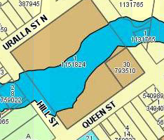  Future development will be required to manage stormwater in accordance with the provisions of Council’s guidelines in force at the time.
- Planning for Bushfire Protection | Yes | Yes | Lot 30 DP793510 contains only buffer bushfire prone land. The planning proposal does not affect land that is covered by bushfire mapping.  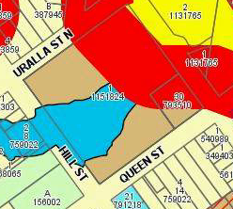  Lot 14 Lot 14 DP787477 is not identified as bushfire prone.

- Regional Planning

Direction | Applicable to Uralla LGA | Consistent | Reason for inconsistency or comment
- Implementation of Regional Strategies | No | Not Applicable
- Sydney Drinking Water Catchment | No | Not Applicable
- Farmland of State and Regional Significance on the NSW Far North Coast | No | Not Applicable
- Commercial and Retail Development along the Pacific Highway, North Coast | No | Not Applicable
  - Revoked
  - Revoked
  - Revoked
- Second Sydney Airport: Badgerys Creek | No | Not Applicable
- North West Rail Link Corridor Strategy | No | Not Applicable
- Implementation of Regional Plans | Yes | Yes | The planning proposal is in accordance with the New England North West Regional Plan 2036.

- Local Plan Making

Direction | Applicable to Uralla LGA | Consistent | Reason for inconsistency or comment
- Approvals and Referral Requirements | Yes | Yes | The planning proposal does not entail provisions which increase approval and referral requirements as outlined in the Direction.
- Reserving Land for Public Purposes | Yes | Yes | The planning proposal facilitates removal of the reservation for public purposes only. .
- Site Specific Provisions | Yes | Yes | The planning proposal does not impose any development standards or requirements in addition to those already contained in the principal environmental planning instrument being amended.

- Metropolitan Planning – Directions 7.1 to 7.6 do not affecting the Uralla Local Government Area

